The Cost Accounting (CO) module of SAP provides information to managers & decision makers to understand where the company's money is being spent. It not restricted by any legal requirements as in case of FI & is essentially an internal cost accounting tool.

**What should i know?**

**Cost Center**

1. Create Cost Center
2. Post to a Cost Center

**Internal Order**

1. All About internal Order
2. Settlement Of Internal Orders To Cost Centers

**Profit Center**

1. Profit Center
2. Postings To Profit Center
3. Profit Center Standard Hierarchy
4. Assignment of Cost Centers To Profit Center
5. Assignment of Materials To Profit Center

**Must Know!**

1. Important Tables in CO Module
2. Comparison Between Cost Center, Profit Center and Internal Order

## How to Create a New Cost Center

To create a Cost Center , Enter **KS01**into SAP transaction code box.

[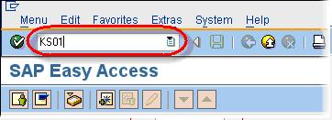](http://www.guru99.com/images/sap/2010/10/sap-create-cost-center.jpg)

In the next SAP screen

* Enter the new cost center number.
* Enter the validity dates of the new cost center.

**Optional -**In the **Reference** section:

* In the **Cost Center** field, you can enter a reference cost center if the details are similar to the new cost center.
* In the **Controlling Area** field, you can enter the reference cost center's controlling area.

In this tutorial, we will create a cost center without a reference. Click Master Data Button

[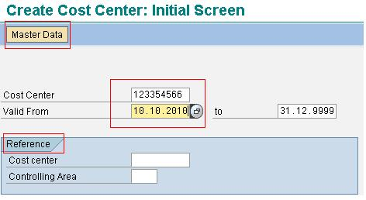](http://www.guru99.com/images/sap/2010/10/sap-create-cost-center-1.jpg)

In the **Names**section:

* In the **Name** field, enter the name of the new cost center.
* In the **Description** field, enter a description for the new cost center.
* In the **Basic Data** section:
* Enter the **Person Responsible**.

In the **Basic Data** section:

* Enter the **Person Responsible**
* Select **W (Administration)** for **Cost Center Category**.
* Select the **Hierarchy area**.
* Enter the **Company Code**.
* The **Currency** will default based on the earlier selections.

[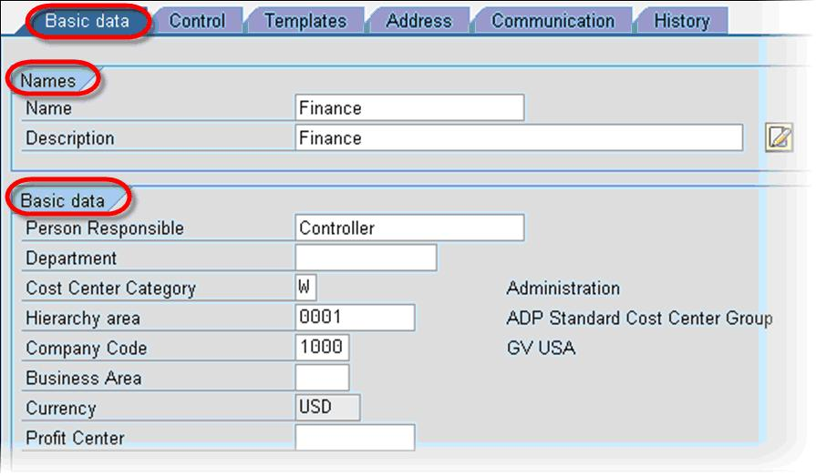](http://www.guru99.com/images/sap/2010/10/sap-create-cost-center-2.jpg)

On the **Control** tab select the appropriate indicators.

[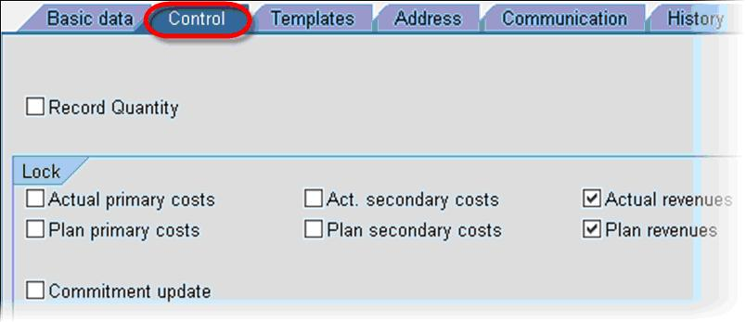](http://www.guru99.com/images/sap/2010/10/sap-create-cost-center-3.jpg)

Click Save. New Cost Center is created.

# 

**Why A Cost Center is Required?** It is the location where the costs are incurred.It can be setup based on areas of responsibility, functional requirements, allocation criteria, geographical locations or activities or services provided. Its purposes is to provide cost related information in Overhead Cost [Accounting](http://www.guru99.com/accounting.html) for which cost centers are grouped into units of decision making, control and responsibility. To map this structure, Cost center is placed in cost center standard hierarchy. **How To Create Cost Center Groups** Enter Transaction Code KSH1 in the SAP Command Field

[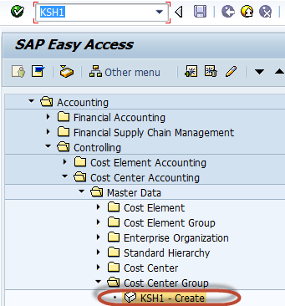](http://www.guru99.com/images/sap/2012/07/CrCostCtrGrp01.png)

In the next screen , Enter the Cost Center Group ID to be created

[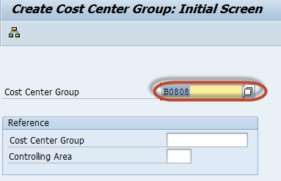](http://www.guru99.com/images/sap/2012/07/CrCostCtrGrp02.png)

In the next screen , Enter the Cost Center Group Description

[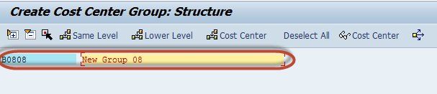](http://www.guru99.com/images/sap/2012/07/CrCostCtrGrp03.png)

Press 'Save'  button in the SAP Standard Toolbar for the Creation of the Cost Center Group

[ Creation Of Cost Center and Cost Center Groups](http://www.guru99.com/images/sap/2012/07/CrCostCtrGrp04.png)

Other Noteworthy SAP transactions-

**KS02** to **Change** Cost Center  
**KS03** to **Display** Cost Center  
**KS04**to **Delete** Cost Center

## How to Post To Cost Center

Enter Transaction Code FB50 in the SAP Command Field   In the next screen , Enter the Following

1. Enter the Document date
2. Enter the Company code
3. Enter G/L Account for the Debit Entry which is to be posted to the Cost Center
4. Enter Debit Amount
5. Enter the Cost Center in which the Amount is to be posted
6. Enter G/L Account for Credit Entry
7. Enter Credit Amount

[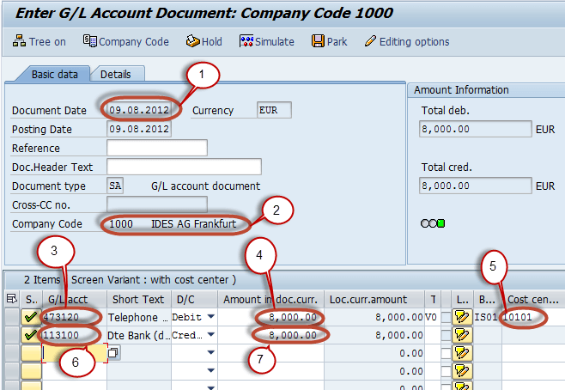](http://www.guru99.com/images/sap/2012/08/CostPost03.png)

Press 'Save' Button for the SAP Standard Toolbar to post the Document

[Postings To Cost Center ](http://www.guru99.com/images/sap/2012/08/CostPost02.png)

Check the Status bar for the Document Number of the Successful Entry.

[Postings To Cost Center ](http://www.guru99.com/images/sap/2012/08/CostPost04.png)

## All About Internal Order in SAP

### Why Internal Order is Required?

Internal orders  describe individual jobs within a controlling area. Orders support action-oriented planning, monitoring, and allocation of costs. You can use internal orders to:

1. Monitor internal jobs settled to cost centers (overhead orders)
2. Monitor internal jobs settled to fixed assets (investment orders)
3. Offsetting postings of accrued costs calculated in CO (accrual orders)
4. Display the cost controlling parts of Sales and Distribution customer not affect the core business of the company (orders with revenues)

We can use overhead orders for detailed controlling for a particular object or activity. All costs related to this object or activity are assigned to the relevant order. We can use orders as internal cost objects.   
  
For example if the company participate in 2 trade fair to target new clients .   
  
Without Orders ,  we post costs for the two trade fairs directly to the cost center responsible for supporting these events. As external costs and internal activities have the same cost elements on the same cost center, we cannot easily determine which event created which costs.This means that we cannot make any further analyses for comparison purposes.  
  
A further advantage is the wide variety of planning and budgeting functions provided for orders.   
  
As With Orders , each event receives its own overhead order,  the costs are collected separately. The settlement function allocates the order costs to the cost center responsible for supporting the trade fairs, which provides you with the organizational view of the costs. This enables us to analyze and compare the results of the trade fairs, even after the settlement has been made.

## Creating Internal Order

Enter Transaction code KO04 (Order Manager) in the SAP Command Field

[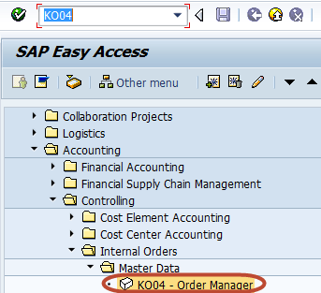](http://www.guru99.com/images/sap/2012/08/Crinorder01.png)

In the next screen ,Press 'Create' button in the application toolbar to create a new internal order

[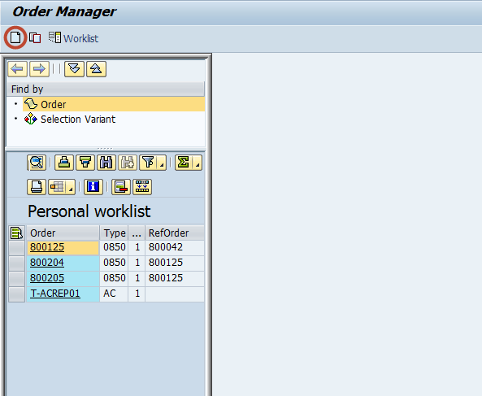](http://www.guru99.com/images/sap/2012/08/Crinorder02.png)

In the next dialog box, Select the order type to be created

[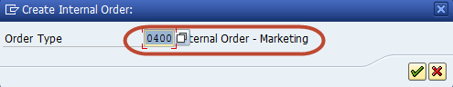](http://www.guru99.com/images/sap/2012/08/Crinorder03.png)

In the next screen, Enter the following data

1. Enter the Company Code
2. Enter the Business area
3. Enter the Object Class of the Order
4. Enter the Profit Center
5. Enter the Cost Center responsible for the internal order

[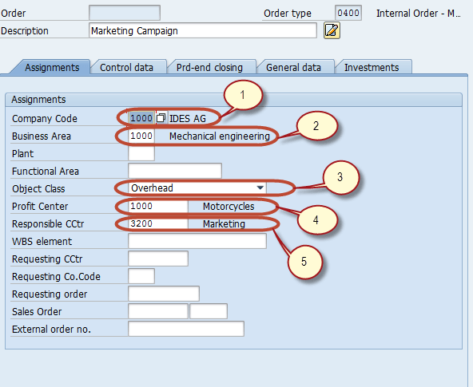](http://www.guru99.com/images/sap/2012/08/Crinorder04.png)

Press 'Save' button in the SAP standard toolbar , to create the internal order

[Creation of Internal Order](http://www.guru99.com/images/sap/2012/08/Crinorder05.png)

Check the status bar for the newly created internal order number

[Creation of Internal Order](http://www.guru99.com/images/sap/2012/08/Crinorder06.png)

## Settlement Of Internal Orders To Cost Centers

Enter Transaction Code KO02 in the SAP Command Field

[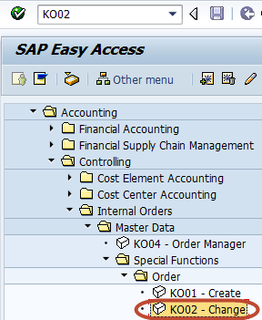](http://www.guru99.com/images/sap/2012/08/SetInorCc01.png)

In the next screen , Enter the Internal Order for which settlement is to be done

[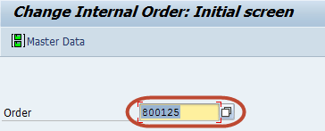](http://www.guru99.com/images/sap/2012/08/SetInorCc02.png)

In the next screen , Select the Settlement Rule Button from the Application Toolbar

[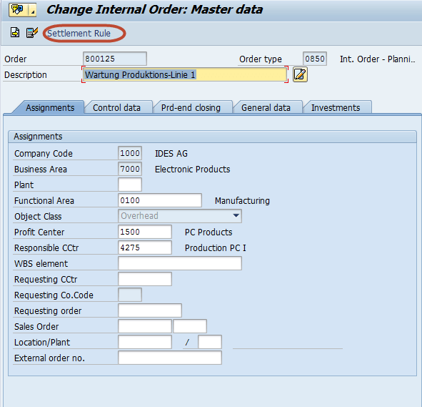](http://www.guru99.com/images/sap/2012/08/SetInorCc03.png)

In the next screen, Enter the Following

1. In the Category Column enter 'CTR' for cost center
2. In the Settlement receiver Column enter the Cost Center in which the Order is to be settled
3. In the percent column , Enter the percentage amount which is to be settled
4. In the settlement type , Enter 'PER' for periodic settlement.

[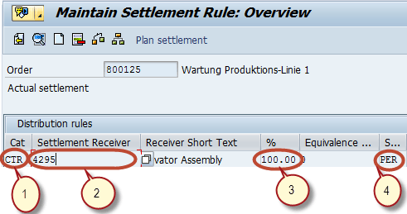](http://www.guru99.com/images/sap/2012/08/SetInorCc04.png)

Press 'Save' button from the SAP Standard Toolbar to save the Settlement Rule and come back to the SAP Main menu .

[Settlement Of Internal Orders To Cost Centers ](http://www.guru99.com/images/sap/2012/08/SetInorCc05.png)

Enter Transaction code KO88 in SAP Command Field

[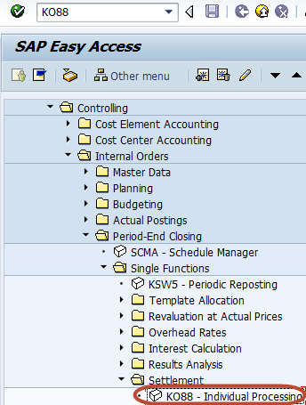](http://www.guru99.com/images/sap/2012/08/SetInorCc06.png)

In the next screen , Enter the Following entries and  run the settlement

1. Enter the Order for which the settlement rule is maintained
2. Enter the Period for settlement
3. Enter the Fiscal Year
4. Uncheck the Test Run
5. Press 'Execute' Button to run the settlement

[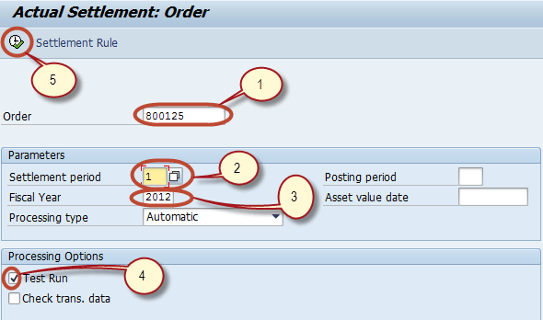](http://www.guru99.com/images/sap/2012/08/SetInorCc07.png)

## All About Profit Center

### Why A Profit Center is Required

The Primary objective of  Profit Center is to represent an independent organizational subunit that operates practically independently in the market, bears responsibility for it's own costs and revenue , and can be expanded to become an investment center or can be treated as a Company within a company.The Profit center approach embodies the increasing re-establishment between internal and external accounting, functioning as a connecting link between two accounting concepts.Profit Center Accounting  helps in answering the following questions :

1. How much is the revenue?
2. How much is the cost of goods manufactured?
3. How much is the contribution margin?
4. How much is the administrative and sales costs?
5. How much is the operating profit?

ROI , EVA and cash flow analyses are possible at profit center level.

## Creation of Profit Center

Enter Transaction code KE51 in the SAP Command Field

[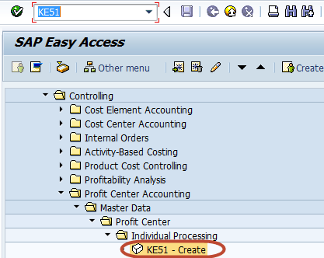](http://www.guru99.com/images/sap/2012/08/Crprofitctr01.png)

In the next screen , Enter the controlling area in which the Profit Center is to be created

[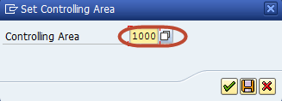](http://www.guru99.com/images/sap/2012/08/Crprofitctr02.png)

In the next screen, Enter a unique Id for the Profit Center

[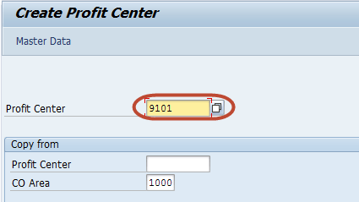](http://www.guru99.com/images/sap/2012/08/Crprofitctr03.png)

In the next screen, Enter the Following

1. Enter the name of the profit center
2. Enter a short description of the profit center
3. Enter the person responsible for the profit center
4. Enter the profit center group for which the profit center belongs to.

[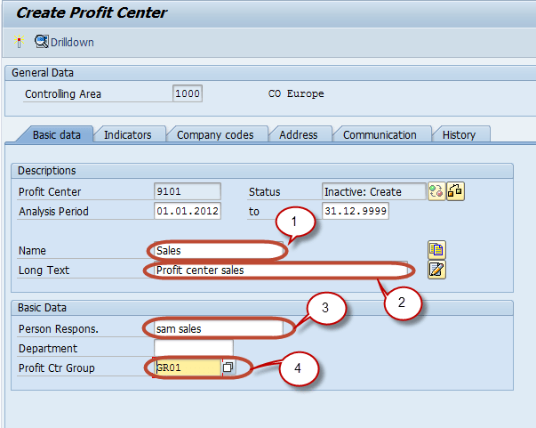](http://www.guru99.com/images/sap/2012/08/Crprofitctr04.png)

Press 'Save' button , for saving the profit center from the SAP Standard Toolbar

[Creation Of Profit Center and Profit Center Groups ](http://www.guru99.com/images/sap/2012/08/Crprofitctr05.png)

The Profit is saved in the inactive mode

. [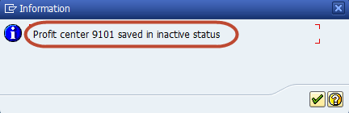](http://www.guru99.com/images/sap/2012/08/Crprofitctr06.png)

Press the 'Activation' Button for the activation of the profit center from the Application Toolbar

[Creation Of Profit Center and Profit Center Groups ](http://www.guru99.com/images/sap/2012/08/Crprofitctr07.png)

Check the Status bar for the status of creation of profit center.

[Creation Of Profit Center and Profit Center Groups ](http://www.guru99.com/images/sap/2012/08/Crprofitctr08.png)

## Profit Center Group

Enter Transaction Code KCH1 in the SAP Command Field

[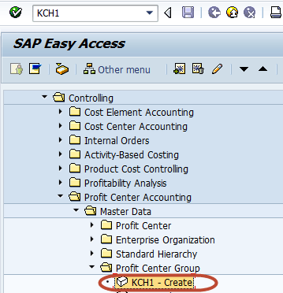](http://www.guru99.com/images/sap/2012/08/Crprtctrgrrp01.png)

In the next screen , Enter the Controlling area in which the profit center group is to be created

[](http://www.guru99.com/images/sap/2012/08/CrCostCtrGrp01A.png)

In the next screen, Enter a unique Id for the Profit center group to be created

[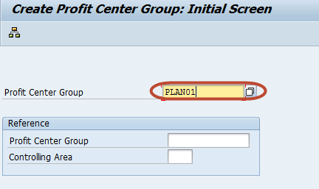](http://www.guru99.com/images/sap/2012/08/Crprtctrgrrp021.png)

In the next screen, Enter a short description for the Profit center group

[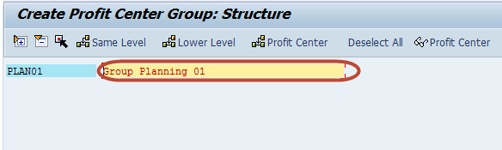](http://www.guru99.com/images/sap/2012/08/Crprtctrgrrp03.png)

Press 'Save' button , from the SAP Standard Toolbar to create the profit center group

[Creation Of Profit Center and Profit Center Groups ](http://www.guru99.com/images/sap/2012/08/Crprtctrgrrp04.png)

Check the Statusbar for the creation of the profit center group

[Creation Of Profit Center and Profit Center Groups ](http://www.guru99.com/images/sap/2012/08/Crprtctrgrrp05.png)

## Profit Center Planning

Planning Process is not a one-time activity, but rather an iterative process, which is usually performed in several steps.Profit center planning is an integral part of your overall company planning. The integral character of business planning is particularly apparent within the context of Profit Center Accounting, as the planning data used here is largely created in other applications (such as Cost Center Accounting) and can be supplemented or changed in Profit Center Accounting. Profit center planning is part of shortterm business planning and thus encompasses a span of one fiscal year. During the profit center planning process, Individual planning areas are combined into an integrated planning network. We can use various plan versions in order to depict various planning Profit center planning offers us the following methods of planning:

1. Copying existing plan or actual data to a plan
2. Posting plan data by period or simultaneously by transaction from other applications
3. Manual planning of profit centers
4. Distribution and Assessment of data between profit centers
5. Various plan reports for comparison of different plan versions

## How to do Posting to Profit center in SAP

**Posting to Profit Center Via Financial Document (FI Interface)**  
Enter Transaction code FB50 in the SAP Command Field

[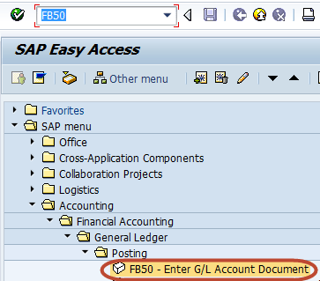](http://www.guru99.com/images/sap/2012/08/PostPfCtr01.png)

In the next screen , Enter the following header data

1. Enter Document Date
2. Enter Company code

[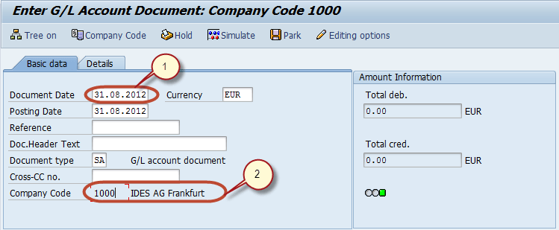](http://www.guru99.com/images/sap/2012/08/PostPfCtr021.png)

Enter the Following Line Item Data

1. Enter Debit G/L Account
2. Select Debit
3. Enter Debit Amount
4. Enter Credit G/L Account
5. Select Credit
6. Enter Credit Amount

[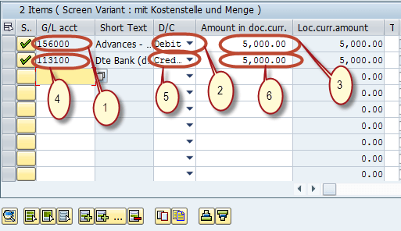](http://www.guru99.com/images/sap/2012/08/PostPfCtr03.png)

After Enter the Line items ,

1. Select the Debit Line Item
2. Press Choose Detail button

[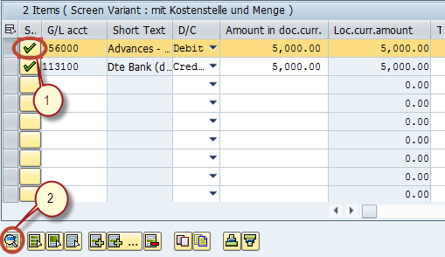](http://www.guru99.com/images/sap/2012/08/PostPfCtr04.png)

In the next detail line item screen, Enter the Profit Center

[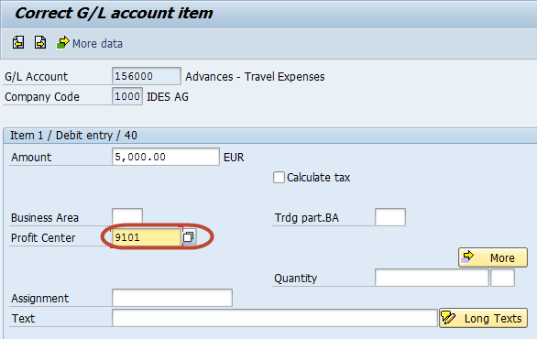](http://www.guru99.com/images/sap/2012/08/PostPfCtr05.png)

Press 'Save' button from SAP standard toolbar to post the document

[ Postings To Profit Center](http://www.guru99.com/images/sap/2012/08/PostPfCtr06.png)

Check the status bar for the Document number for the confirmation of posting

[ Postings To Profit Center](http://www.guru99.com/images/sap/2012/08/PostPfCtr07.png)

## Creation Of Profit Center using Standard Hierarchy

[](http://click.linksynergy.com/fs-bin/click?id=bt30QTxEyjA&offerid=323058.45&subid=0&type=4)

Standard hierarchy is a tree structure for grouping all profit centers which belong to a controlling area. When creating a profit center, you must assign it to a group (node) of the standard hierarchy. This ensures that all profit center of a controlling area are grouped in one node.This helps in reconciliation purposes. We can maintain the standard hierarchy  from the application menu or in Customizing . Customizing also provides a function which allows you to create profit center groups by copying cost center groups. If our cost center structure is similar to our profit center structure, we can use this function to copy the cost center standard hierarchy to create our profit center standard hierarchy.

Enter Transaction Code KCH1 in SAP Command Field

[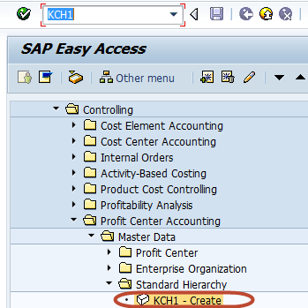](http://www.guru99.com/images/sap/2012/08/CrPrtCtrHchy01.png)

In the next screen,Enter the Controlling Area for which you want to create the Profit Center Standard Hierarchy

[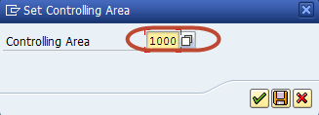](http://www.guru99.com/images/sap/2012/08/CrPrtCtrHchy02.png)

In the next screen,Enter the main node Profit Center Group of the Standard Hierarchy for the Controlling Area to be created

[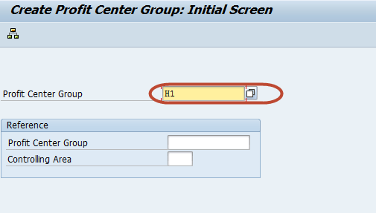](http://www.guru99.com/images/sap/2012/08/CrPrtCtrHchy03.png)

In the next screen, Enter subnodes or sub profit center groups of the Standard hierarchy

[](http://click.linksynergy.com/fs-bin/click?id=bt30QTxEyjA&offerid=323058.45&subid=0&type=4)

[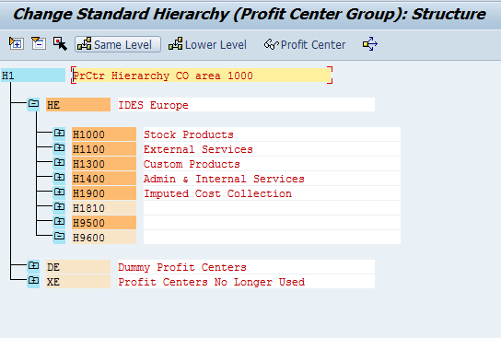](http://www.guru99.com/images/sap/2012/08/CrPrtCtrHchy04.png)

Similarly Assign profit center to the profit center groups

. [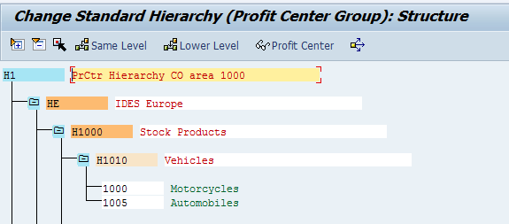](http://www.guru99.com/images/sap/2012/08/CrPrtCtrHchy05.png)

Save the structure, and check the status bar for the changes be saved

[Creation of Profit Center Standard Hierarchy](http://www.guru99.com/images/sap/2012/08/CrPrtCtrHchy06.png)

A typical Standard Hierarchy display

[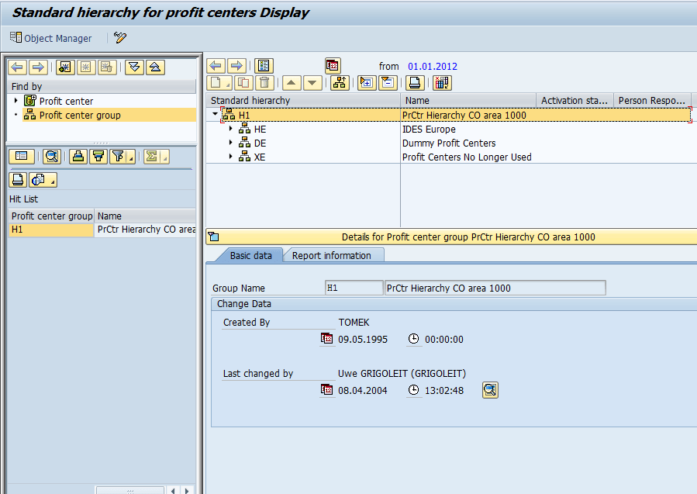](http://www.guru99.com/images/sap/2012/08/CrPrtCtrHchy07.png)

## How to assign Cost Centers to Profit Center

Enter Transaction Code SPRO in the SAP Command Field

[ Assignment of Cost Centers To Profit Center ](http://www.guru99.com/images/sap/2012/08/Cotopc01.png)

In the next screen, Select 'SAP Reference IMG

' [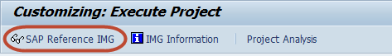](http://www.guru99.com/images/sap/2012/08/Cotopc02.png)

In the next screen , 'Display IMG' Follow the menu path Controlling->Profit Center [Accounting](http://www.guru99.com/accounting.html) -> Assignments of Account Assignment Objects to Profit Center ->Assign Cost Centers

[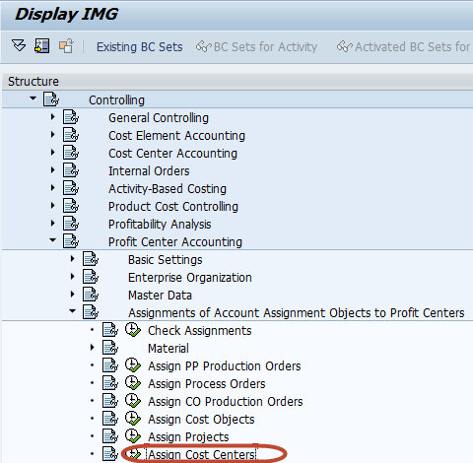](http://www.guru99.com/images/sap/2012/08/Cotopc03.png)

In the next screen, Enter the cost center to be assigned to a profit center

[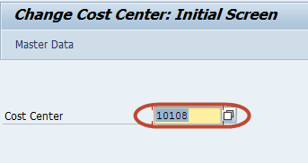](http://www.guru99.com/images/sap/2012/08/Cotopc04.png)

In the next screen , Enter the profit center to which the cost center is assigned

[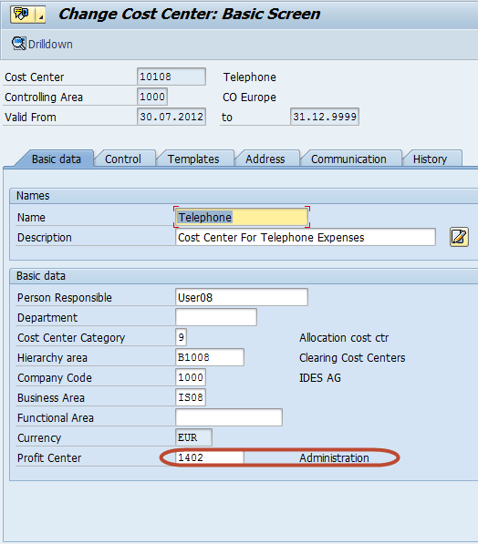](http://www.guru99.com/images/sap/2012/08/Cotopc05.png)

Press 'Save' button from the SAP Standard toolbar , for the saving the changes.

[ Assignment of Cost Centers To Profit Center ](http://www.guru99.com/images/sap/2012/08/Cotopc06.png)

## How to assign materials to profit center in SAP

Enter Transaction Code SPRO in the SAP Command Field

[ Assignment of Materials To Profit Center ](http://www.guru99.com/images/sap/2012/08/AsMatPrCtr01.png)

In the next screen, Select the 'SAP Reference IMG' button

[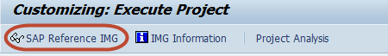](http://www.guru99.com/images/sap/2012/08/AsMatPrCtr02.png)

In the next screen , 'DISPLAY IMG' follow the menu path Controlling -> Profit Center [Accounting](http://www.guru99.com/accounting.html) -> Assignments of Account Assignment Objects to Profit Center ->Material ->Assign Material Masters

[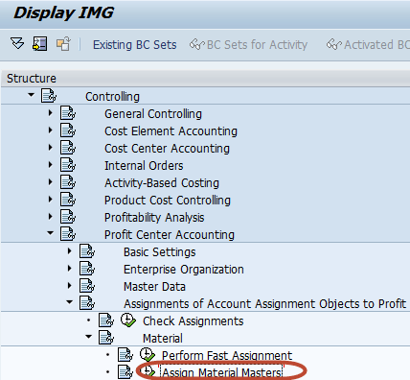](http://www.guru99.com/images/sap/2012/08/AsMatPrCtr03.png)

In the next screen, Enter the Material ID for which the profit center is to be assigned

[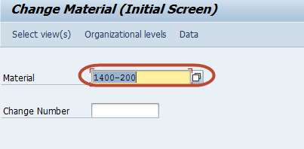](http://www.guru99.com/images/sap/2012/08/AsMatPrCtr04.png)

In the next dialog box , Select 'Sales General/Plant' View of the material master

[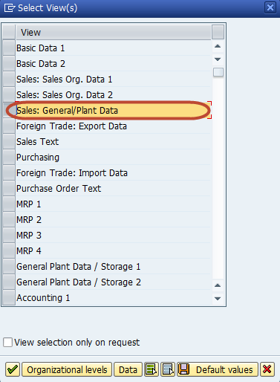](http://www.guru99.com/images/sap/2012/08/AsMatPrCtr05.png)

In the next dialog box , Enter the Following

1. Enter the Plant for the Material
2. Enter the Sales Organization
3. Enter the Distribution channel

[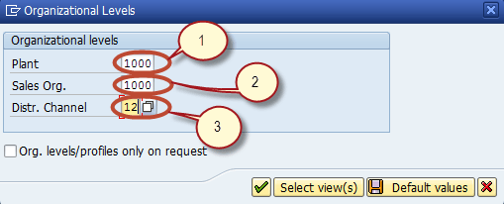](http://www.guru99.com/images/sap/2012/08/AsMatPrCtr06.png)

In the next screen, Enter the Profit Center in the Master[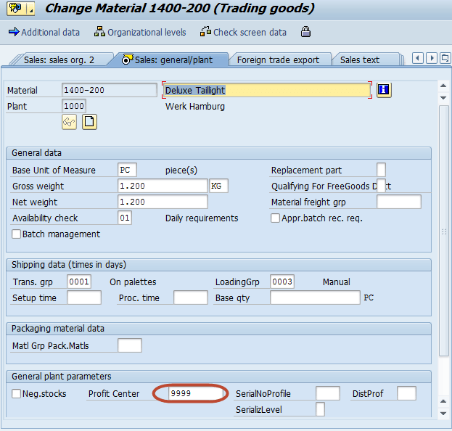](http://www.guru99.com/images/sap/2012/08/AsMatPrCtr07.png)

Press 'Save' button from the SAP Standard Toolbar to complete the assignment

[ Assignment of Materials To Profit Center ](http://www.guru99.com/images/sap/2012/08/AsMatPrCtr081.png)

## List of important tables in Controlling Module (CO Tables)

**CO Tables :**

**Overhead Cost Controlling**

A132                       Price per Cost Center

A136                       Price per Controlling Area

A137                       Price per Country / Region

COSC                      CO Objects: Assignment of Original Cost Sheets

CSSK                       Cost Center / Cost Element

CSSL                       Cost Center / Activity Type

KAPS                       CO Period Locks

**Overhead Cost Controlling:**

**General Services**

CSKA          Cost Elements

CSKB          Cost Elements

CSKS          Cost Center Master Data

CSLA          Activity Master

**Overhead Cost Controlling**

COBK          CO Object: Document Header

COEJ           CO Object: Line Items

COEJL         CO Object: Line Items for Activity

COEJR         CO Object: Line Items for SKF

COEJT         CO Object: Line Items for Prices

COEP          CO Object: Line Items (by Period)

COEPL         CO Object: Line Items for Activity

COEPR         CO Object: Line Items for SKF

COEPT         CO Object: Line Items for Prices

COKA           CO Object: Control Data for Cost

COKL           CO Object: Control Data for Activity

COKP           CO Object: Control Data for Primary Planning

COKR           CO Object: Control Data for Statistical key Figures

COKS           CO Object: Control Data for Secondary Planning

**Cost Element Accounting (Reconciliation Ledger)**

COFI01      Object Table for Reconciliation

COFI02      Transaction Dependent Fields

COFIP         Single Plan Items for Reconciliation

COFIS         Actual Line Items for Reconciliation

**Cost Center Accounting (Cost Accounting Planning RK-S)**

A138           Price per Company Code

A139           Price per Profit Center

**Overhead Orders:**

**Application Development R/3 Cost Accounting Settlement**

AUAA          Settlement Document: Receiver Segment

AUAB           Settlement Document: Distribution Rules

AUAI            Settlement Rules per Depreciation Area

AUAK           Document Header for Settlement

AUAO           Document Segment: CO Objects to be Settled

AUAV           Document Segment: Transactions

COBRA          Settlement Rule for Order Settlement

COBRB          Distribution Rules Settlement Rule Order Settlement

**Overhead Orders:**

**Cost Accounting Orders**

AUFK             Order Master Data

AUFLAY0    Enttity Table: Order Layouts

**Profit Center Accounting**

CEPC                      Profit Center Master Data Table

CEPCT                    Texts for Profit Center Master Data

CEPC_BUKRS     Assignment of Profit Center to a Company Code

GLPCA                  EC-PCA: Actual Line Items G

LPCC                   EC-PCA: Transaction Attributes

GLPCO                   EC-PCA: Object Table for Account

GLPCP                   EC-PCA: Plan Line Items

**PCA Basic Settings:**

**Customizing for Profit Center Accounting**

A141                      Dependent on Material and Receive profit center

A142                      Dependent on Material

A143                      Dependent on Material Group

## Compare Cost center, Profit center and Internal order

  Lets quickly compare the three entities  **Profit center:**

1. Profit center is an organizational unit in accounting that reflects a management-oriented structure of the organization for the purpose of internal control.
2. Profit Center Accounting evaluates the profit or loss of individual, independent areas within an organization.
3. These areas are responsible for their costs and revenues.

**Cost Center:**

1. Cost Centers are the organizational units within a controlling area that represents a location where costs occur.
2. Organizational divisions can be done on the basis of functional, settlement-related, activity-related, region/section/department related, and/or responsibility-related, to monitor actual and plan figure standpoints
3. Where cost is captured.

**Internal Order:**

1. An internal order is used to accumulate cost for a specific project or task for a specific time period.
2. An internal order is therefore used for a short period with a specific deadline.